DRAFT
THRIVING COMMUNITIES STRATEGY 2023-2027

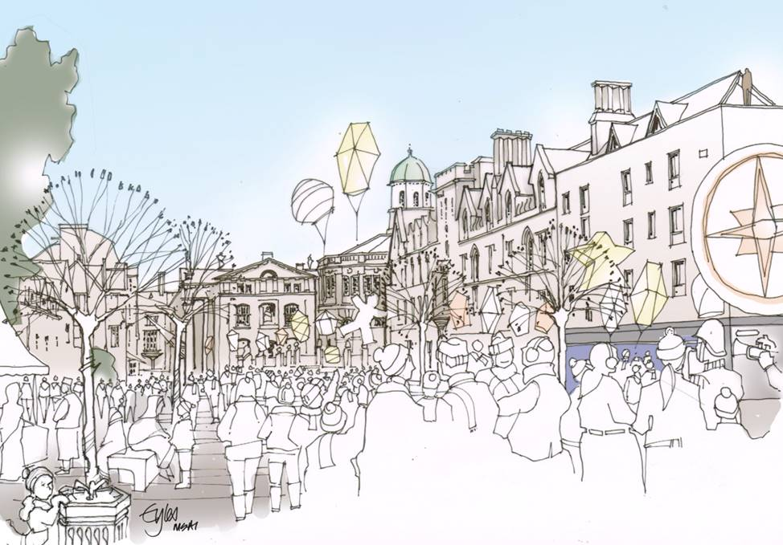

18th November 2022

Contents
Contents 2
Foreword 3
1. Executive summary 5
2. Introduction 6
3. How we developed the strategy 9
4. Thriving Communities insights 10
Society 10
Finance and social value 10
Location 11
5. What this strategy covers 11
Supporting Oxford’s 2050 Vision 11
Our Corporate Strategy 12
6. How we will work 15
7. Our aims 16
8. The 4Ps and action plans 17
People 17
Pride 18
Place 20
Progress 22
9. Words and phrases we have used 23

Foreword (draft)

This strategy has been written following our Thriving Communities City Conversation where we have heard from hundreds of people – I’d like to start by thanking so many people for giving us their time and working with us to deliver our shared ambitions. Communities across the city are facing new and deepening hardships from the cost of living crisis. We have written this strategy to ensure fairness and to build on the sense of community and care that so many people have shown over recent years.

The Michael Marmot report, Build Back Fairer, shows the scale of the challenge we face and why we need a new approach. Soaring inflation and the cost of living crisis are making this even more important. As the UK emerges from the pandemic (and crashes into a cost of living crisis) it would be a tragic mistake to go back to the normality that existed before. It was marked, in England over the past decade, by a stagnation of health improvement that was the second worst in Europe, and by widening health inequalities. There is an urgent need to do things differently: to build a society based on the principles of social justice, racial justice, gender justice and climate justice; to reduce inequalities of income and wealth; to build a society that responds to the climate crisis while achieving greater health equity. In Oxford we are setting out how we will do this. We urgently need a government strategy that aims to build an economy centred on the achievement of health, wellbeing and sustainable futures, rather than narrow economic goals. Our aim is to help strengthen communities and focus our resources where they are most needed, in the face of huge funding cuts to local government since 2010.

We will adapt to local circumstances, at times connecting people, others times facilitating, signposting or commissioning. This way of working requires an approach where we build trust and seek to understand people’s lived experience, adapting our support to best meet individual needs. It also requires culture change inside the council and changing how we work.

We will increasingly work with community groups and partners, seeking out new relationships with people who want to make a difference. We will look for opportunities to build relationships with underrepresented groups and where the greatest inequalities exist. We know we can achieve better outcomes by involving more people and ensuring diversity in our teams. We also know that language really matters. We will ensure our language is easy to understand and inclusive. We have also produced an easy-read version of this strategy and made some accompanying short videos.

This way of working is aligned with our wider goals and aims, and our Council Strategy. Thriving Communities is one of the four interconnected areas of our Council Strategy, alongside our commitment to tackling climate change, building an inclusive economy and affordable housing. We have just completed a £13 million leisure centre decarbonisation programme making innovative improvements to Oxford’s leisure centres. We aim to support the delivery of our plan with Oxfordshire County Council’s wider strategic ambitions laid out in the Health and Wellbeing Strategy and Children and Young People’s Plan, and those of our colleagues working in Oxfordshire County Council Public Health.

I have created a short video to summarise why this work is so important and want to thank people for their incredible work across our inspirational, but unacceptably unequal city.
A video will be embedded into this photo before it goes to cabinet
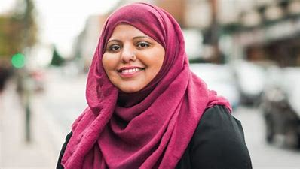
Councillor Shaista Aziz
Cabinet Member for Inclusive Communities & Culture

Executive summary

Oxford’s Thriving Communities Strategy brings together leisure, culture, and our work with communities to tackle inequalities. We will do this by encouraging well-designed neighbourhoods and parks where healthy lifestyles are the norm (sometimes called healthy place shaping) developing skills, ensuring growth is inclusive, strengthening communities and improving access.

The gap between the poorest and richest in our society continues to grow, the rich are getting richer and the poor are getting poorer – austerity, the pandemic and the cost of living crisis hurt those with the least the most. These inequalities are detailed in Oxfordshire’s Joint Strategic Needs Assessment which provides information about the county's population and the factors affecting health, wellbeing, and social care needs. Our ability to tackle inequalities is also being compromised by continued recruitment challenges in industries such as leisure and rising energy costs which are placing significant strain on service delivery.

Leisure, culture, and community services provide the most accessible, inclusive and cost-effective solutions for prevention and rehabilitation, and positively impact in many other ways, including health and wellbeing, educational attainment, employment, economic productivity, crime reduction, loneliness and engaging disadvantaged communities. This strategy is about connectivity and collaboration – ensuring we effectively join up our efforts to help create a more equal city. The strategy shows how things connect, where possible we have used shared outcomes such as our ambition that every child can learn to swim.

Our leisure centre contract expires in 2024, which provides an opportunity for these facilities to better meet changing community needs. We have been investing in our community facilities to ensure they provide modern, flexible spaces that are fit for purpose, carbon-friendly and long-term sustainable spaces. This investment includes developments at Rose Hill, Barton, Bullingdon and East Oxford Community Centres, with work planned at Blackbird Leys Community Centre, we have also invested in the Museum of Oxford. We want our community facilities to be accessible and well-governed with a diverse and representative group of trustees, staff and volunteers.

To make sure we don’t lose the learning from the pandemic, we have implemented new locality structures with teams from across the Council working more collaboratively with Oxford’s communities. Increasingly, we will align our work with partners, generating shared insights and co-creating better services for residents. We have developed our Thriving Communities Principles, and while these are not set in stone, they show how we will work with communities, collaborating, and building on what’s strong.

Introduction

This strategy sets out how we aim to work with partners and our diverse communities to build back fairer and create thriving communities.
To create thriving communities, we want everyone to have the best chance of good physical and mental health at all stages of life. This means promoting good health and social connections, valuing difference and being active in volunteering are important to thriving communities. We need to work together to ensure everyone in Oxford can access leisure, culture and community opportunities.
This strategy aims to create a shared purpose for the Council, partners and communities, making the most of the resources we have, ensuring our investments have the greatest possible impact, and that our work is based on insight. Our approach is centred on local people - redirecting wealth back into local communities and placing the control of the benefits into the hands of local people, this is often called Community Wealth Building.
COVID-19, and the ongoing cost of living crisis, have increased inequalities, which are expected to get worse unless we start taking action now. Like most councils, our budgets are under immense pressure: we have seen a £7 million reduction in funding because of austerity measures. While we will do all we can to protect services for the most vulnerable, we will have tough choices to stay in budget and need to change how we work.

Oxford’s inequality in data
- Oxford is the UK’s second most unequal city.
- Ten out of Oxford’s 83 neighbourhoods are amongst the 20% most deprived in England.
- 22% of adults have no or low educational qualifications.
- Average house prices in Oxford are 17.3 times average earnings at over £500,000.
- One in four of children lives below the poverty line (after housing costs), rising to 36% of children in Blackbird Leys.
- Life expectancy is much shorter in Oxford’s most deprived areas - 13.8 years for men and 11.2 for women.
We cannot tackle these deeply ingrained inequalities unless we take a whole system approach, not just to health but to living in our city. This strategy is focused on prevention and addressing the root causes of issues that create poor opportunities and experiences.

“We need to stop just pulling people out of the river.
We need to go upstream and find out why they’re falling in.”
– Archbishop Desmond Tutu

Ethnicity and poverty are linked, with all the associated issues for health, education, employment and life chances. The Runnymede Trust, a leading UK race equality thinktank, has published a report on how the UK cost of living crisis will disproportionately affect people of colour. Black and minority ethnic people are currently 2.5 times more likely to be in poverty than white people.

We are developing new structures so our teams can work more collaboratively in Oxford’s neighbourhoods. Our vision is to place residents at the heart of service delivery; focusing on prevention and meeting residents' needs including those who are in crisis or need our help the most. Maximising people and place potential, reducing inequalities, benefiting from digital engagement, and facilitating solutions to deliver meaningful and tangible outcomes. We will increasingly align our work with partners, creating shared insights and more joined-up solutions.

This strategy brings together four outdated strategies (Leisure, Culture, Community Centres and our Children and Young Persons’ Strategy) that had overlapping outcomes and uses a simple 4Ps framework:
- People – implementing our Thriving Communities Principles (section 7) – e.g. doing things with people not to them, and building on what works well
- Pride – celebrating diverse cultural heritage, encouraging trust and belonging and ensuring inclusivity
- Place – inclusive spaces and places
- Progress –a range of ways to demonstrate the impact of our work and continually learn.
This strategy sits alongside the Housing, Homeless and Rough Sleeping Strategy, Oxford’s Economic Strategy, and the Net Zero Oxford Action Plan. It has been developed in a rapidly changing environment, with fundamental changes in the way we live our lives.
Health is intrinsically linked to inequality, but better societal factors can make a significant difference to good health. The February 2021 health and social care white paper shows the need for a more integrated system, with one in three patients admitted to hospital as an emergency now having five or more health conditions, up from one in ten a decade ago.

One of the clearest examples of how crises like the pandemic, and now the cost of living, increases inequality is seen in research on the social gradient of health. This shows that the lower one's social and economic status, the poorer one's health is likely to be. The importance of these social determinants of health are highlighted below in a quote by Duncan Selbie, former Chief Executive of Public Health England.

“A decent job, a good home and friends are more important to good health than the NHS”.

Working differently creates an opportunity to integrate our services, such as leisure and culture, with partners like the NHS to develop a preventative, person-centred, long-term approach. Our contract for leisure services expires in 2024, so we now have a window of opportunity to reimagine how Oxford’s leisure centres could play a more substantial role in tackling health inequalities that is more integrated with work by health and Oxfordshire County Council public health providers. The recently produced Fit for the Future: the role of district councils in improving health and wellbeing makes a strong case for integrating council-run leisure and wellbeing services into the health system.

How we developed the strategy

We started work on the strategy pre-COVID, supported by a fantastic group of partners, and undertook a Local Government Association (LGA) Peer Review which provided helpful insights. We paused the work during the pandemic to focus on emergency support.

Restarting in 2022, we ran a series of workshops to create a discussion paper which was used over a 10-week Thriving Communities City Conversation. We spoke to hundreds of partners, community groups and residents. Feedback on this approach has been very positive, with people valuing the opportunity to discuss real issues that would then help to shape the strategy.

The Census 2021 will provide invaluable insight into the social and demographic changes that have occurred over the last decade. Census data is now gradually being released, which will allow us to better understand the characteristics of our local communities including deprivation and inequalities. Already we know our population has grown by 6.7% over the past 10 years to 162,100. Alongside consultation and community conversations, this information will help our understanding of our communities.

We know it is important to take a whole system approach - looking at how the bigger picture connects - and that equality, diversity, inclusivity and a sense of belonging need to be at the heart of the strategy. Oxford City Council’s Thriving Communities Strategy dovetails with Oxfordshire County Council’s public health work and Children’s Services; and of the Buckinghamshire, Oxfordshire and Berkshire West Integrated Care System partners (BOB ICS).

Video 2 embedded into a picture for the cabinet version, adding - This video shows why this connectively is so important)

Based on these insights, this strategy recognises the need to be flexible, to treat people as individuals and to shape our approach so it helps local people find local solutions to their priority issues.

Thriving Communities insights

Below are some illustrative insights about Oxford and the leisure and cultural opportunities it offers to residents.

Society
- There is a strong correlation between deprivation and physical inactivity. Most deprived areas in Oxford have low physical activity rates and high rates of obesity which contributes to lower life expectancy. Areas in Barton, Blackbird Leys, Greater Leys, Littlemore and Rose Hill have the lowest proportion of active adults in the City.
- There is a link between deprivation and the preference for exercising in leisure centres over-exercising in informal settings such as parks, or at home.
- Oxford has become more digitally competent since COVID-19 forced businesses and individuals to quickly adapt. However more granular data shows that digital exclusion, including the cost of data and devices, affects deprived areas in the southern neighbourhoods. Some older people are less inclined to use digital communication channels.
- Communities are staying more local and discovering what’s on their doorstep.

Finance and social value
- Every £1 of City Council core funding investment into cultural organisations in 2019-20 resulted in more than £50 of additional funding/earned income.
- For every £1 invested in a leisure centre, £23 in value is created according to research by the King’s Fund.
- By reducing inactivity, life expectancy between the least and most deprived would reduce from 12 to 8 years, according to research by East Anglia University.
- A 2014 review showed that c£18.3 million of social value (the monetary equivalent of the importance people place on the changes in their lives) is generated by Oxford’s leisure centres each year. Our tennis programmes alone generate c£336k of social value.
- However, there is a c£1.5 million maintenance backlog across all community centres and c£15.2 million potential costs in repairs and maintenance of our leisure centres over the next 25 years (based on 2018 condition surveys).

Location
- Oxford has a variety of leisure facilities; public, private and boutique offers, including a high number of museums, green and blue spaces and arts venues for its size.
- The majority of residents are within a 20-minute walk of a leisure centre.
- Arts and cultural organisations are predominantly based in the city centre -there are 13 museums and art galleries in Oxford, of which the majority are located in the centre of the city. There are currently six main theatres in Oxford, all bar the Pegasus Theatre are located in the city centre.
- 26% of arts and culture audiences live within four miles of the venues visited.
- Community centres are concentrated in the city centre and East Oxford.
- Over 90 green spaces, of varying sizes, can be found across the City, including parks and nature reserves.

What this strategy covers

The Thriving Communities strategy covers the 4Ps set out earlier. There are numerous connections across all areas of work, by understanding and joining up these up we can create better support for residents.

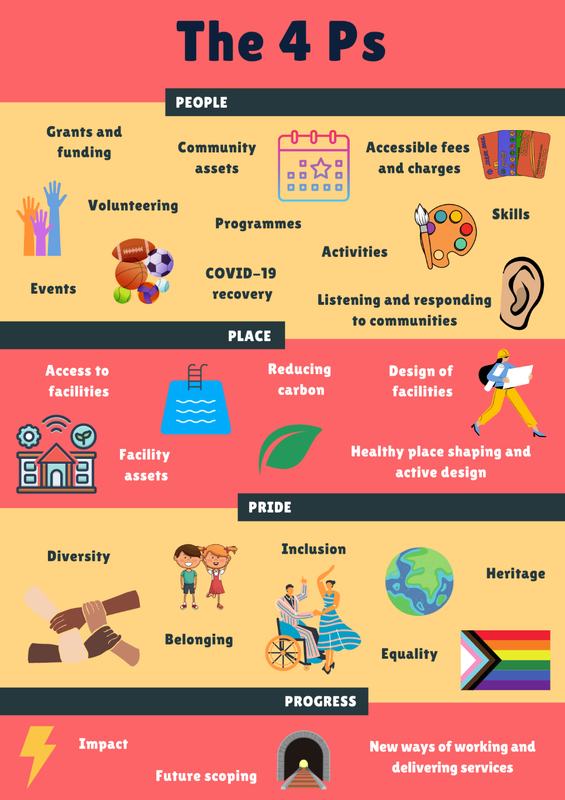

How it all connects

Supporting Oxford’s 2050 Vision

The Oxford2050 vision shows our plans for the future of the city. Thriving Communities are central to this vision, connecting each theme and playing a primary role in the people and communities and culture and leisure sections.

Our Corporate Strategy

Thriving Communities is one of the four mutually supportive areas of the Council’s Corporate Strategy. The following diagram shows the connections between Thriving Communities, Housing, Environment and the Economy. Together they help create our vision for communities:

“Oxford’s diverse communities should be equipped, supported and enabled to tackle inequality and ensure everyone is able to play a full part in the life of our city.”
– Corporate Strategy, 2020-2024

To achieve this vision, we know the importance of working with communities and partners. An example of collaboration between local authorities and the community is the emerging Oxfordshire Food Strategy. This sets out how Oxfordshire’s food system can help achieve priorities for health and wellbeing, climate change and biodiversity loss, and fair income and employment.

Connectivity is a key part of the strategy; projects, objectives and partners often overlap across the council which can be confusing, making it challenging for people to effectively join up their work. The graphic below shows how these strategies connect to achieve the shared outcomes.

“Create shared agendas and ensure everyone understands how
they fit into the bigger picture.”
– City Conversation participant, 2022

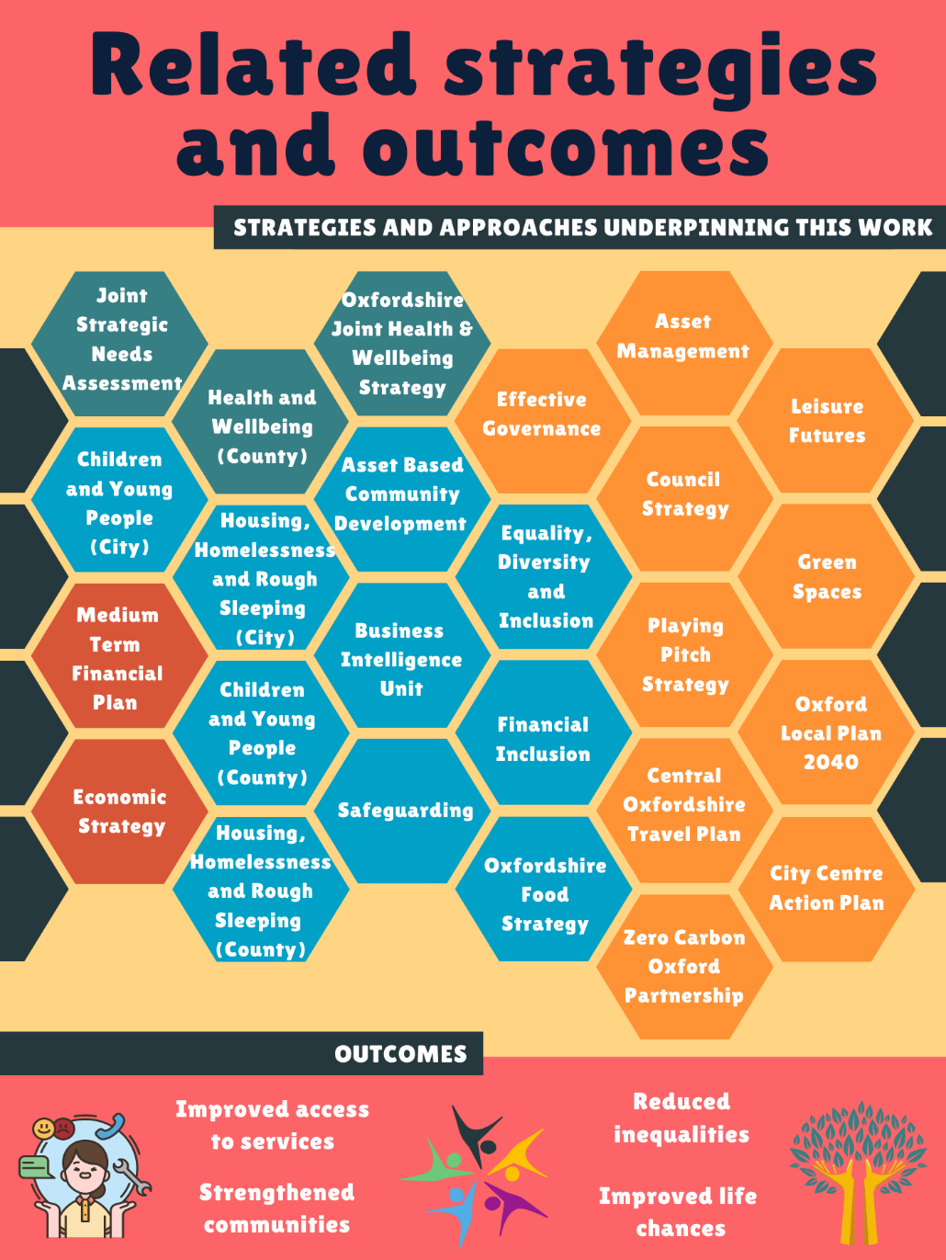

How we will work

We are increasingly focused on creating collaborative, innovative and sustainable approaches to supporting communities. A few examples include Oxford’s Community Impact Fund; the insight-led Community Impact Zone; the Cultural Education Partnership; the creation of a twinning programme between Oxford University colleges and local primary schools; establishing the Museum Development Trust to attract more funds to the Museum of Oxford; and Life Chances where we are piloting the use of Social Impact Bonds to support children and young people. We will share our learning and use insights from connected pieces of work such as the Council’s child poverty review.

These innovative approaches have collectively levered in over £1m of revenue over the past three years, alongside creating social value, additional resources and delivering significant outcomes. The Community Impact Fund has created further value by generating match funding for organisations.

We believe that the way we work is as important as what we do. We have explored using an asset-based community development approach, which is also used by partners such as adult social care in what they call the Oxfordshire Way. People fed back that while the approach makes sense, the title is confusing and we need to make sure it is relevant to Oxford. As such we have created -

Six Thriving Communities Principles
During the City Conversation we tested our thriving communities principles, which were very positively received:
- Doing with, not to – we know that involving people and working together rather than imposing solutions upon people creates far better outcomes.
- Building on what’s strong, not what’s wrong – we know that a positive approach based on developing what is already working well also helps create better outcomes.
- Collaboration – we will give time to think through who needs to be involved and what our role should be.
- Always learn – we will facilitate shared learning and won’t be afraid to try new things – even if mistakes are made – sometimes they provide the greatest learning …
- We will use clear language that reinforces our values – e.g., we will talk about people - not cases, and understanding someone’s situation rather than assessing their needs.
- Use meaningful ways to measure and demonstrate the impact of our work – while numbers are useful, other methods such as sharing stories provide more in-depth insight.
The strategy’s principles should not be set in stone; it important to be flexible and review as we go.
(video 3 – alt text This short video brings these principles to life)

Our aims

- To target our resources where they will have the greatest impact.
- To move towards an enabling approach using our Thriving Communities Principles.
- To embed lessons that we have learnt during the COVID-19 pandemic.
- To adapt and integrate our services so they can react to changing community needs, working more closely with partners and connecting with the integrated care system.
- To ensure that our people (employees) have the skills to support communities.
- To foster a sense of belonging.
- To provide many different opportunities to be active.
- To develop a sustainable, inclusive and accessible leisure and community offer.
- To enable a vibrant, innovative and sustainable cultural sector and economy.
- To use a variety of methods to demonstrate how we improve life chances and strengthen communities.

The next section of the strategy shows how we will achieve these aims. While the strategy is high-level and designed to show our approach and the key activities, we also have a detailed internal action plan where we track progress. A progress update will be taken to the Council's cabinet each year to ensure there is good governance and transparency around our commitments.

The 4Ps and our actions

People

A more equitable and supportive society is needed, COVID and the cost of living crisis are further increasing inequalities.

What you told us in the city conversation
For many people, this was the most important part of the strategy, being clear on how we will work and ensuring that we build on the learning from the pandemic – taking time to build trust and continue to work with communities.

You liked the clarity of our approach, articulated in the Thriving Communities Principles. You valued the space to talk and saw value in ‘joining things up’, and told us that the City Conversation provided a great opportunity to further your understanding, share your ideas and make new connections.

We had lots of conversations about barriers, you told us that a combination of cultural and social barriers make it hard to take part in leisure and cultural activities, including cost, lack of time, barriers to access, being ‘not for them’ and people's lives being too chaotic.

You told us that a key part of accessibility was improving our communication and making places and spaces more welcoming. You also wanted one place where people could find out about what’s available.

“Ensure you are targeting a diverse range of members of the community, not just those with the 'loudest' voice – this can be facilitated through organisations on the ground who work closely with and are active within the community as a whole.”
– City Conversation participant, 2022

What we will do
- Implement and encourage others to work with and adopt Oxford’s Thriving Communities Principles.
- Continue to develop our work in localities, making sure our teams are joined up and able to address the root cause of residents' problems.
- Add our services to and help promote the County Council’s Live Well Oxfordshire website as a central resource for finding out what’s available to support people in the community.
- Facilitate increased cross-sector collaboration for bids to the Community Impact Fund and help bring in more funding from local, regional and national funders.
- Hold an annual Thriving Communities Forum with partners to create an inclusive and diverse space to continue the city conversation.
- Work with our partners such as the Department for Work and Pensions to create skills, employment and development opportunities.
- Work with the County Council, and other partners, to create a more integrated approach to supporting children and young people by building on the Ready by 21 Framework, collaborative bids to funds such as the Youth Investment Fund and to continuing to collaborate on projects such as the Cultural Education Partnership Feeling Safe mental health project.
- Make better use of data so we can take an insight-led approach; embracing digital innovation, increasing digital connectivity, and supporting an open data philosophy.
- Work more closely with partners and the community to co-produce and promote activities such as You Move and Move Together.
- Ensure Oxford’s community services are sustainable and better connected, helping to deliver a range of local outcomes as well as outcomes for national strategies such as Arts Council England’s Let’s Create Strategy and Sport England’s Uniting the Movement.
- Facilitate preventative services to become part of a more integrated health and social care model, with increased social prescribing and GP referrals into a broader range of inclusive options.
- Adopt a whole systems approach to enable fair and sustainable access to good food in line with the Oxfordshire Food Strategy.

Pride

We want everyone in Oxford to feel a sense of local pride and be free to be who they are and feel like they belong.

What you told us

You were concerned that inequalities are worsening and the harsh economic environment and budget cuts are negatively impacting the poorest people the most.

You were positive about the City Council’s work, you particularly valued the Council’s support over the pandemic when our teams were very visible in the community. You wanted the Council to be transparent and explicit with communities about what we are trying to achieve and you felt that this wasn’t always the case.

You felt some communities were very good with asking for and getting help, people and communities who are most in need often did not know what support was available to them.

You told us that our language and written communication were often hard to understand and that at times you wanted face-to-face contact.

Many people wanted to be more involved with local issues, some wanted guidance, funding or just to know who to speak to. There were conversations that some people needed more support to be able to be involved, or volunteer.
“It is much harder to understand on the phone –
you end up saying ‘yes' when you don’t understand.”
Refugee focus group member, 2022

What we will do
- We will use a variety of images and role models in our communications to inspire people and be inclusive. We will continually challenge ourselves in how we use terms and language so that we can connect with our communities and residents in all our communication and interaction.
- We will produce short videos and an easy-read version of this strategy to make it more accessible.
- We know the value of our workforce representing the community and being embedded within a wide range of local networks. This helps us to support Oxford’s diverse communities. We will continue to build on this through our Equality, Diversity and Inclusion and People Strategies.
- We will continue to champion Equality, Diversity and Inclusion and engage with and facilitate conversations about equality throughout the city, and work to make Oxford an anti-racist through our Anti-Racism Charter.
- We will work with Community Associations and groups such as Friends of Parks to help strengthen their governance to be more inclusive of the local areas they represent and better address diverse local needs.
- We will work in collaboration with refugees, asylum seekers and the migrant community to inform and develop a Local Authority City of Sanctuary Action Plan and ensure the City Council meets its commitment to become an accredited local authority of sanctuary.
- We will continue to promote and celebrate diversity, including publishing a calendar of diversity events and collecting and telling the unique stories and heritage of Oxford’s different communities in the newly renovated Museum of Oxford and online.
- We will enable arts, culture, sport, community activities and grants to provide and promote opportunities for everyone, and foster a sense of pride and belonging in Oxford’s leisure, cultural and community assets.
- We will increase the diversity of people engaged with Oxford’s twin cities and publicise the benefits of our International Links connections.
- We will audit our community spaces and places to make sure they are accessible to everyone.
- We will work to find a burial ground to meet the future needs of the city.

Place
The Council has a crucial role in creating community spaces that help people thrive, from parks and public spaces, through to community and leisure centres.

What you told us

You told us there are lots of great spaces and places across Oxford, but they are not all accessible. This was mainly university green spaces, and some community and leisure centres were seen as being unwelcoming to the wider community. You wanted community spaces and facilities to be better promoted. Several participants in the refugee focus group had never heard of community centres.

You were concerned about the increasing cost to access and maintain Oxford’s leisure and community centres. This would result in people not being able to afford access to them, with lower revenue resulting in deteriorating building conditions, among other negative consequences. You told us that you found it helpful when we combined services such as adding libraries and health services into community centres and felt this could help improve the customer experience and help save on running costs.

You wanted us to improve access to travel facilities, with healthy and safe travel options prioritised, and better linkages with green spaces and parks.

Our thoughts on how we can further improve this
- We will look to provide the best possible leisure service. We will do this through a series of dialogue with potential operators and compare what they offer with an in-house comparator. We will request innovative solutions that balance cost and social value, we will give options such as a longer-term lease and ask for innovative ideas about how the centres could be used to better deliver strategic outcomes.
- We will take a lead in reducing the city’s impact on climate change by working with our leisure partners, communities and Community Associations to implement further decarbonisation improvements, better cycling facilities and improve biodiversity.
- Explore with partners, such as Oxfordshire County Council public health and the NHS how Oxford’s leisure centres, especially those in areas of significant health inequalities can play a greater role in tackling health inequalities.
- Complete our investments in Bullingdon, East Oxford and Blackbird Leys Community Centres, creating fantastic facilities. The modular design of Bullingdon creates a blueprint for future developments.
- We will continue to seek out opportunities to join up our community facilities – to create sustainable spaces for communities. Our preferred approach remains that where possible we want communities to manage community assets.
- We have a map of all community facilities on our website, we will better promote what’s available, especially our inclusive activities such as free swimming for under 17s and produce an animated video to help bring this map to life.
- Ensure that our community facilities are well managed, inclusive and accessible with easy to navigate booking systems.
- We will use the International Society for Physical Activity and Health Eight investments that work for Physical Activity to guide our work to tackle inactivity.
- We will review our parks and green spaces strategy in 2026 and explore the possibility of combining it with the next Thriving Communities Strategy.
- We will trial charging non-Oxford residents a small entry fee to access the Museum of Oxford, generating income to help protect valuable services from the impact of government cuts.
- We will explore opportunities with partners to work with us to deliver services such as youth work, by changing the way some services are delivered we may be able to access new sources of funding.
- Embed healthy place shaping by integrating health prevention into neighbourhoods, helping to create more connected neighbourhoods with cycle and walking routes and providing affordable public transport, particularly focusing on areas with the greatest health inequalities.
- Ensure Oxford is a leader in Active Travel – working with Oxfordshire County Council and ensuring the voices of schools and other partners (such as Cyclox and Oxford Pedestrians Association) are comprehensively included in the delivery of cycling and walking improvements.
- We will work with partners to try and sustain and widen our inclusive community programmes such as GO-Active, Move Together, You Move, health walks, Dancin’ Oxford, GO-Active Families and GO-Active Outdoors. Targeting those who are inactive and/or most in need.
- Expand the offer in Oxford Town Hall via its events spaces, the Museum of Oxford and café to attract a wider audience from the local community and beyond, with the aim to become one of the leading events and cultural venues in the city.

Progress
How we will know if we are achieving our objectives

The ultimate outcomes we want to achieve are for everyone in Oxford to:
- Have a great experience when using Oxford’s places and spaces where they feel safe and enjoy themselves.
- Be able to positively contribute to society; feel connected, accepted and respected for who they are.
- Meet the Chief Medical Officer’s guidelines for physical activity (especially children and young people).

The outcomes within the strategy are shared with partners, and where possible we have adopted shared measures, the measures also link directly into the Council’s key priorities and plans.

In keeping with our meaningful measurement principle we will:
- Use numbers so we are aware of how many people use our services.
- Use metrics to demonstrate value for money.
- Monitor progress against our Thriving Communities Action Plan and produce an annual update.
- Use techniques such as collecting and publishing the stories of our communities and their lived experience of Oxford, case studies and videos to bring outcomes to life and learn from them.

Annual measures of success
Our Communities
- Produce and annually review Locality Plans – these will be based on insight, with a focus on tackling inequalities
- Increase the diversity of recipients of Oxford’s Community Impact Fund
- Increase the diversity of volunteers and trustees – we will focus on our community champions programme, Community Associations, Friends of Parks and the Museum of Oxford.

Reducing inequalities
- Reduce the number of children leaving primary school who cannot swim 25 metres from four to two in ten over the lifetime of this strategy
- Increase the number and diversity of young people taking part in Oxford’s Youth Ambition activities
- Reduce physical inactively in the areas of the city where it is the highest

Customer Excellence
- Increase satisfaction levels with leisure centres
- Continually increase our score in our Customer Service Excellence accreditation
- Achieve accreditation to National quality award schemes such as Quest (the UK quality award scheme Sport and Leisure).

Our Places
- Complete the redevelopment of Bullingdon, East Oxford and Blackbird Leys Community Centres
- Contribute to the Council’s commitment towards pursuing zero carbon Oxford.

Words and phrases we have used

We have tried to keep this document in plain English and easy to read. In parts, we have referred to ideas or programmes that might not mean much to all readers. We have defined these below:

Active travel: Travelling in an active way, for example by foot and bike.

Healthy place shaping: Creating areas that make healthy choices easier, by providing spaces to exercise, local access to daily needs like shops and community spaces, and where it’s easy and safe to walk, cycle and exercise. This includes places like leisure centres and parks, along with (arts and cultural spaces).

Social prescribing: When health professionals refer people to services that are based in the community (e.g. health walks). These can be non-medical and are often delivered through community and voluntary organisations. It can include a supported conversation with a link worker, focusing on what matters to the person (not their condition or disability).

Whole system approach: Taking an overview of all the organisations and interactions people have when accessing a service (e.g. how someone might be referred to a health service) and using this information to better design and improve services.

Meaningful Measures: Showing how we are performing and making a real difference to the lives of our communities.

If you’re unsure of anything in this document and require extra help to understand it, please email us at TCS@oxford.gov.uk or call us on 01865 249811.

Gini co-efficient
The English Indices of Deprivation (2019)
Census (2011)
Centre for Cities (2019)

